|  |
| --- |
| Department of Software Engineering  Mehran University of Engineering and Technology, Jamshoro |

|  |  |  |  |
| --- | --- | --- | --- |
| Course: SWE324 – Distributing Computing | | | |
| Instructor | Rabeea Jaffari | **Practical/Lab No.** | 05 |
| Date | 02 April 2019 | **CLOs** | CLO-4: P3 & P4 |
| Signature |  | **Assessment Score** | 1 Marks |

|  |  |
| --- | --- |
| Topic | To become Familiar with OLTP System Design |
| Objectives | * To Creating applications using Datagram sockets. |

|  |
| --- |
| Lab Discussion: Theoretical concepts and Procedural steps |

|  |
| --- |
| Lab Tasks |
| Submission Date: 09-04-19 |

Task:1

1. HelloInterface

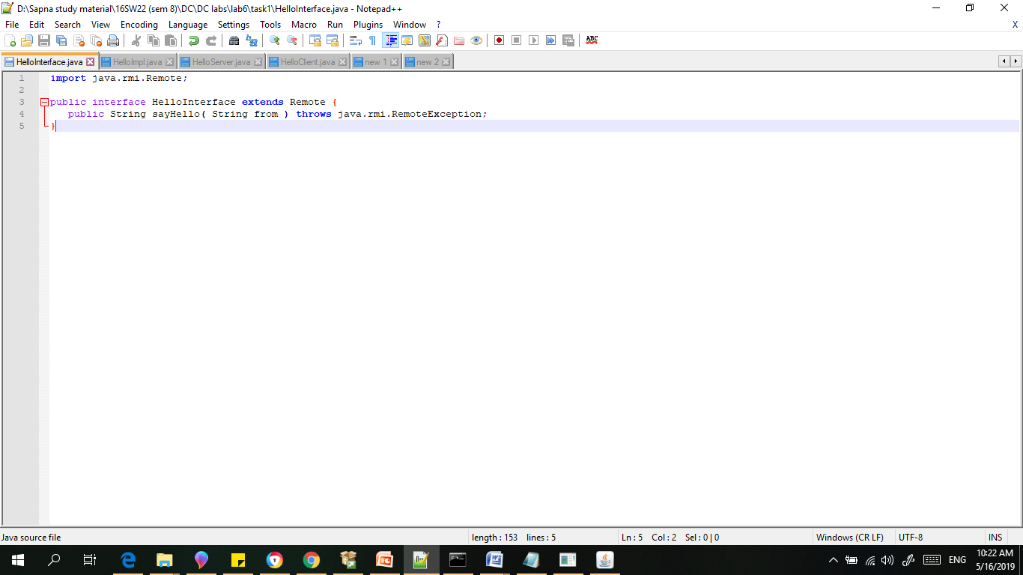

1. HelloImpl

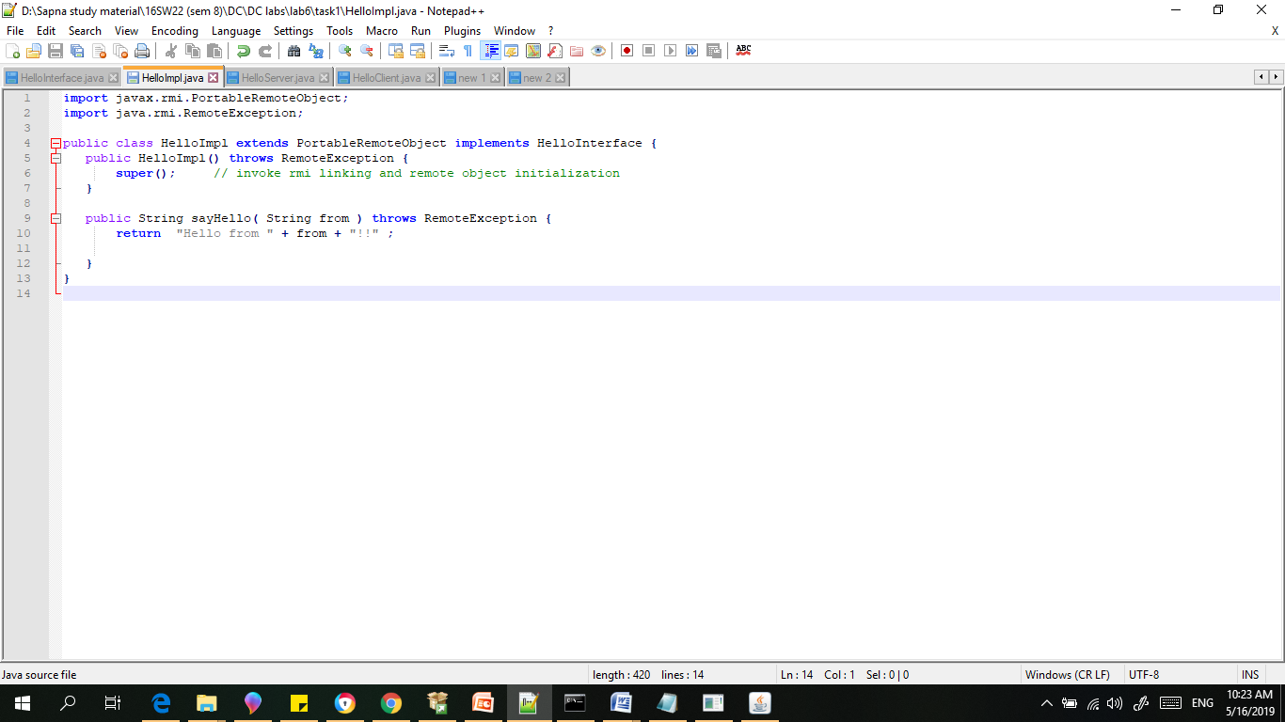

1. HelloServer

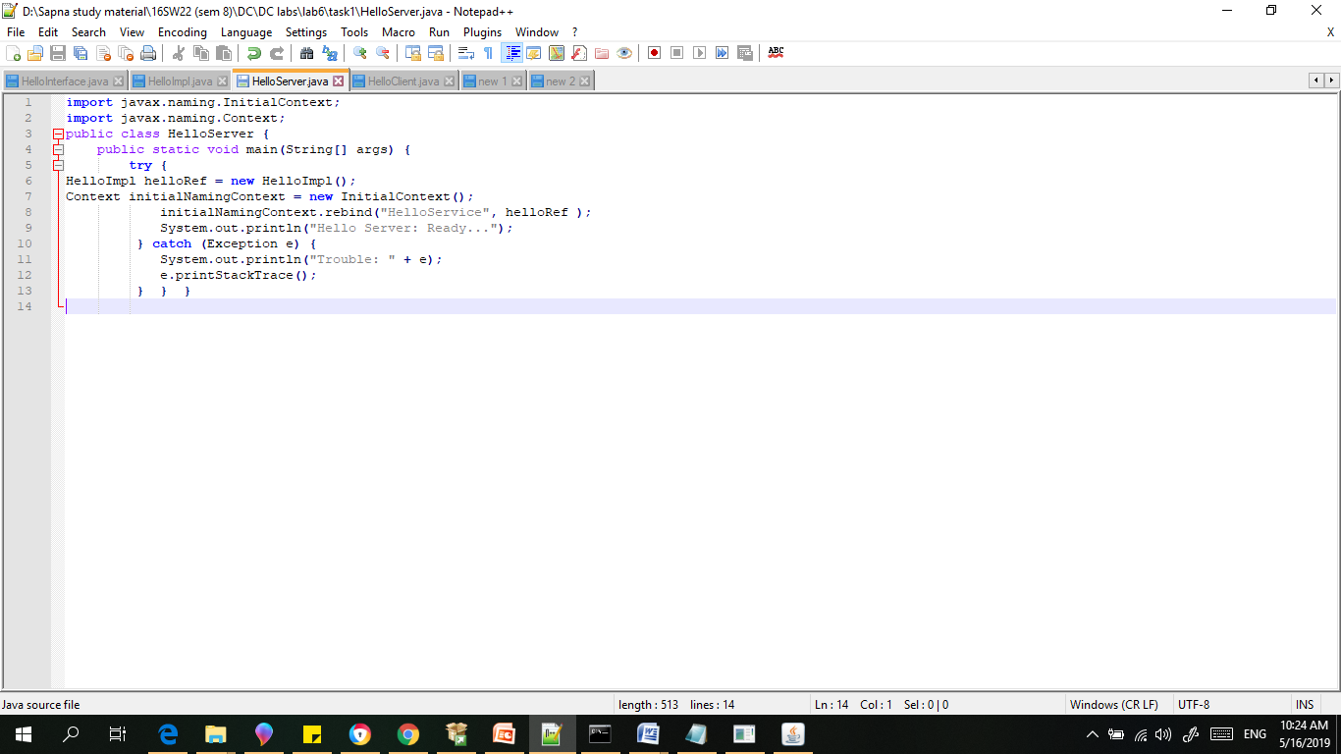

1. HelloClient

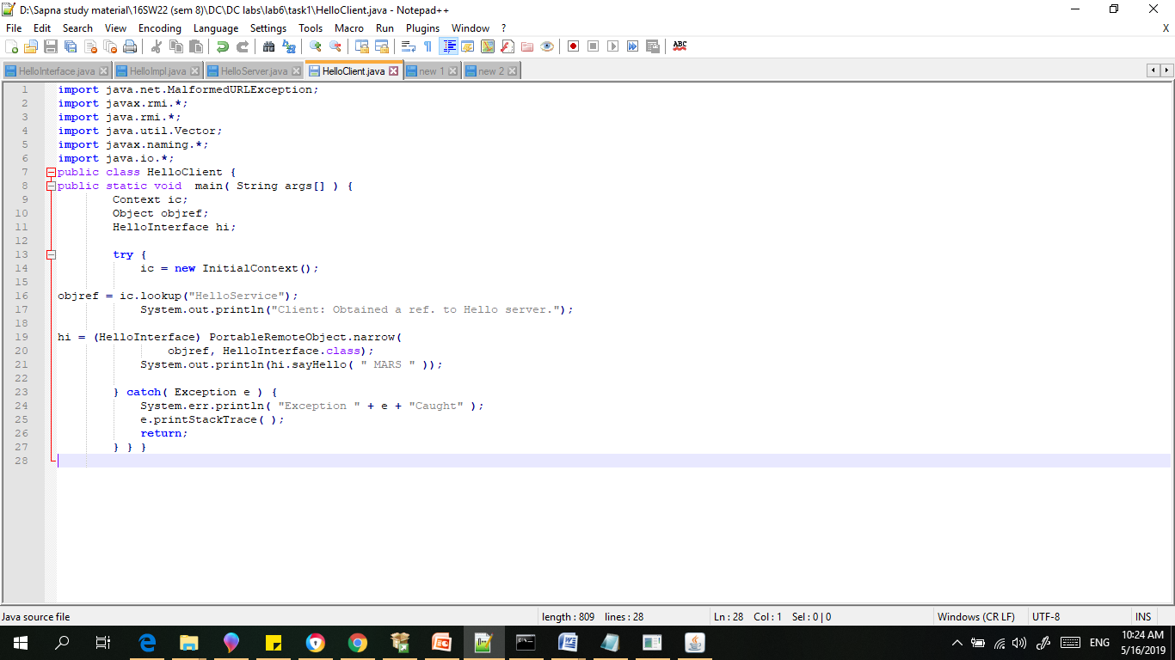

Result:

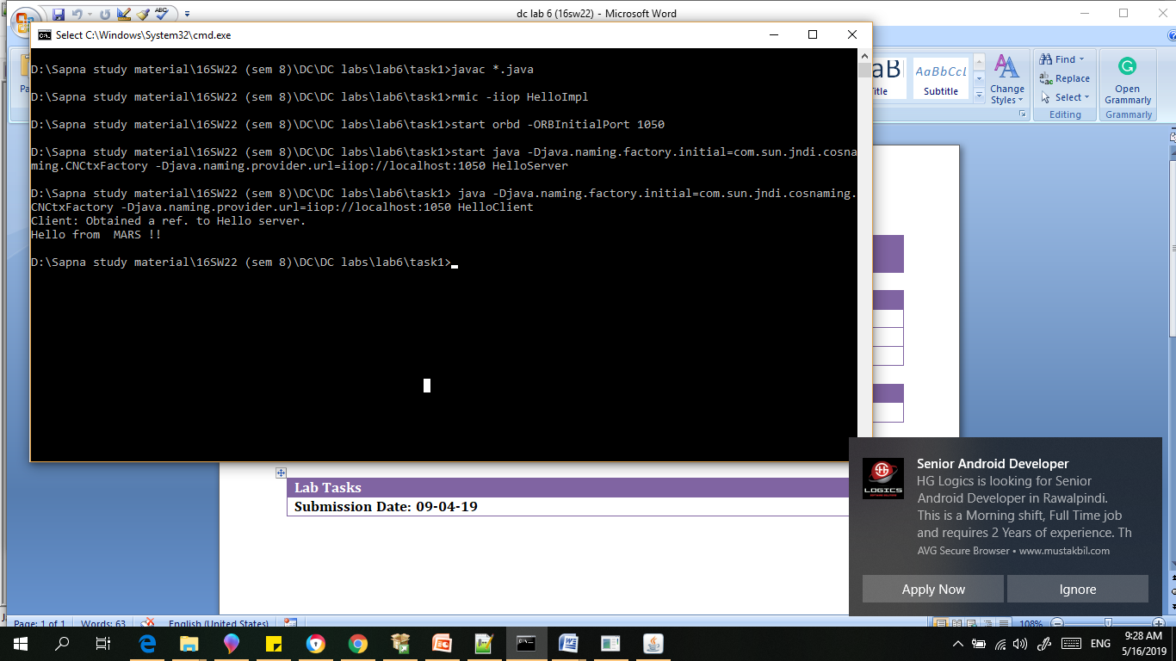

* Create RMI IIOP application in which take a sentence at runtime on the client application and let the server return its reverse.  
  E.g. input could be: subject is distributed computing   
  output should be: computing distributed is subject.

1. HelloInterface

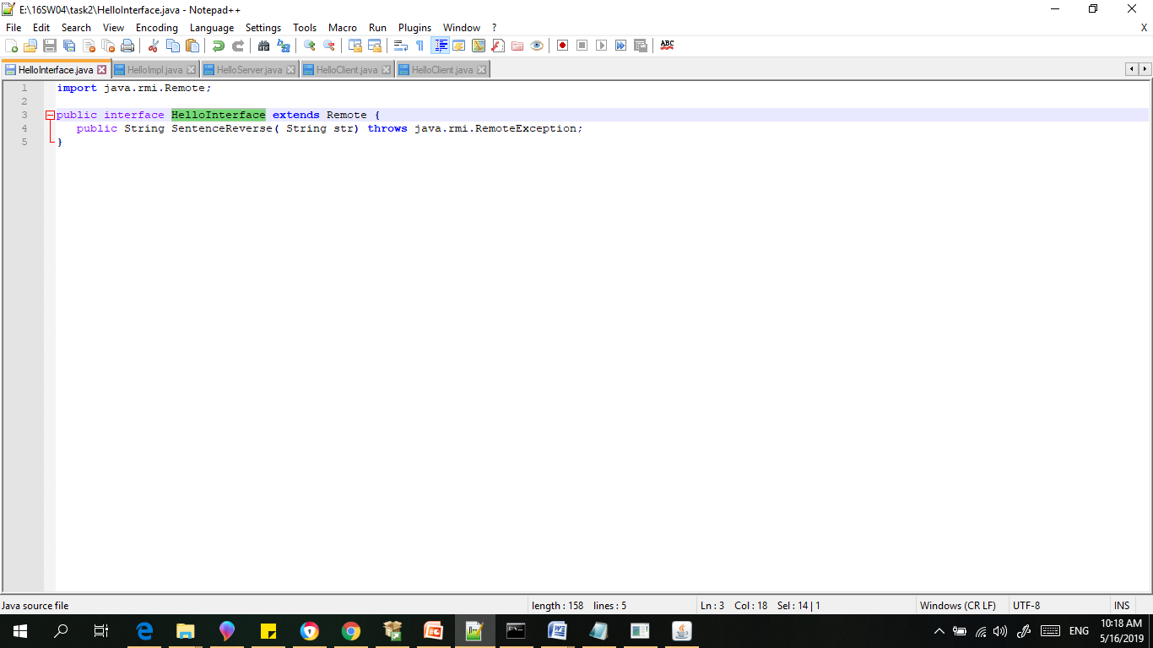

1. HelloImpl

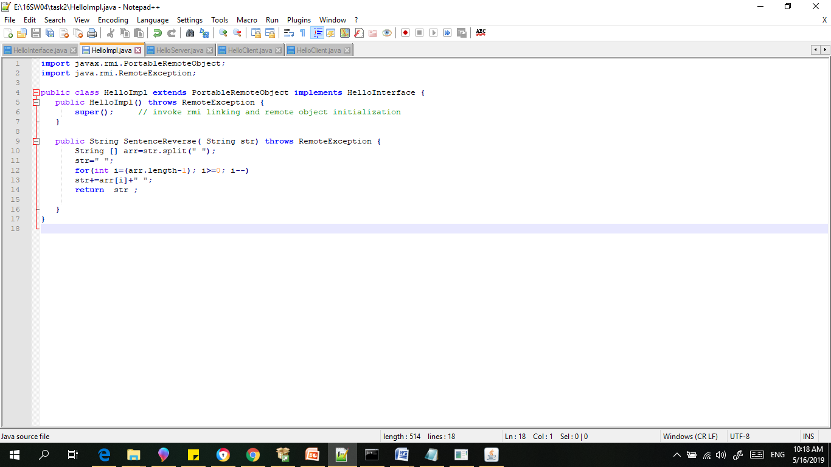

1. HelloServer

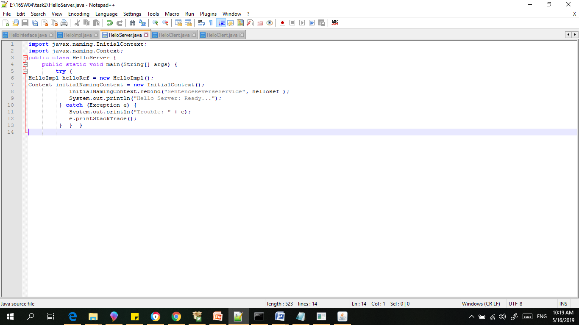

1. HelloClient

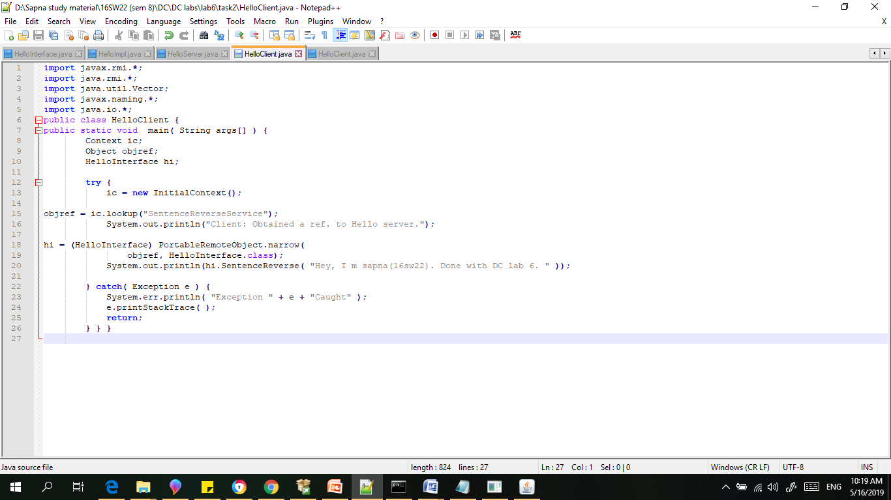

Results:

.